Office of Research on Teaching in the Disciplines

Undergraduate Action Research Paper No. 20

The University of Alabama
Department of Curriculum and Instruction – Elementary Education Program

How can the use of a dialogue journal impact my ability to reach a student struggling with emotional outbursts?

Lacie Gwendolyn Garrett

Research Supervisor: Dr. Melisa Fowler

Dialogue journals are defined as personal written correspondence between a teacher and their students. The teacher may provide prompts to guide students’ writing, or students can write a letter detailing a personal problem affecting their life. Dialogue journals grant teachers the opportunity to form personal relationships with their students, which can help students solve problems and regulate their emotions in a safe environment that promotes a sense of freedom and belonging (Regan, 2003; Staton, 1980). Dialogue journals can also be used to reach students with emotional and behavioral disorders (Regan, 2003) and oppositional defiance disorder (Smith & Bondy, 2007).

This action research was conducted in the 2017-2018 school year in a second grade class at a southeastern public city school. The school contains 278 students; 98.9% of whom are African American. Among the student population, 0.7% are White and 0.4% are Hispanic. This class, specifically, houses 17 students, eight of whom are male and nine of whom are female. In this class, all students are African American. At this school all students receive free breakfast and lunch. After analyzing the socioeconomic status of her students and comparing it to the qualifications to receive free and reduced lunch, the teacher estimates that maybe one or two of the students in her class would not receive free or reduced lunch if a grant the school has received from the federal government did not exist. The school is located in a low income neighborhood. Most students in this class either ride the school bus or walk to school from their homes. The surrounding neighborhoods are characterized by their apartment complexes, a graveyard, local businesses, and throngs of adults socializing outside during the day.

Some of the students in this classroom struggle academically and have social services and special needs accommodations. Despite the high achievement levels of a few of the students, no one receives gifted and talented services because no such services exist at this school. One student in this class, the focal student for this action research case study, is in Tier III for her displayed behavior. She and another student exhibiting problematic behavior work very closely with the counselor, with all three of the second grade teachers, and with the resource teacher on recommendations within their personalized behavior charts. A few of the students in second grade have difficulty reading, so they participate in an intervention group led by one of the second grade teachers. Some of these students also have their exams read to them and are given less difficult passages to read in their centers in class. No other accommodations are given in the general education setting.

Because of the wide range of academic achievement between the students who receive intervention and those who are reading and comprehending above grade level, most instruction is delivered in homogeneous small groups organized by ability. The second grade in this school is departmentalized. There is one math teacher, one writing teacher, and one teacher instructing both social studies and science. All three teachers provide reading instruction. The students in these classes, except for the students who tend to be separated from their peers on most days because of behavioral issues, are seated in groups. Two of the three teachers introduce their lessons with a short whole group lesson and then have the students separate into small groups that operate as learning centers. While one group works with the teacher, the other groups are working on the computer using educational websites, completing written independent work, or independently reading books on their Accelerated Reader (AR) level.

No matter the center or lesson in which the students are engaged, most of the students complete their work. My experiences have led to a perception of the classroom as a safe, loving, yet stern environment in which the students feel safe enough to ask and answer questions and take risks when learning. Although the classroom can be chaotic, students understand the routine and expectations at each center. During center small group time, there are usually not very many behavioral issues except for excessive talking and the behaviors displayed by the focal student.

The focal student of this action research case study, Student A, has difficulties with regulating her emotions. When Student A becomes upset, she cries, screams loudly, stomps, bangs on the table, picks the skin off of her hands, leaves the classroom, and/or stands in the corner refusing to participate with the rest of the class. When she is engaged in such behaviors, it often takes her at least a half-hour to calm down; causing missed instructional time for her and her classmates. Multiple times a day the teacher stops her lesson to address Student A. Sometimes she has to escort Student A to the principal or to the counselor because the student is a serious disruption to the learning environment. Student A also reports feeling “sad,” “mad,” and “like everybody bothers [her] and nobody wants to be [her] friend” because of her frequent, long-lasting emotional outbursts. Student A would benefit from a tool that can help her express and manage her emotions in a way that does not alienate her from her peers or disrupt the class. Therefore, this action research study addresses the question, “how can the use of a dialogue journal impact my ability to reach a student struggling with emotional outbursts?”

Review of Literature

Proactive, positive intervention strategies are most effective in impacting a teacher’s ability to reach students with oppositional defiant disorder (ODD) and emotional and behavioral disorders (EBD). Unlike researchers who solely recommend teachers form relationships with their students and understand the function of their specific behaviors in order to eradicate them, Smith and Bondy (2007) suggest managing the classroom environment is essential for preventing and managing negative classroom behavior. Smith and Bondy specifically studied strategies for eradicating defiant behavior. The Diagnostic and Statistical Manual of Mental Disorders, fourth edition, explains oppositional defiant disorder (ODD) as characterized by a pattern of negative, hostile, and defiant behavior in which students often lose their temper, argue with adults, refuse to comply with requests or rules, deliberately annoy people, blame others for their misbehaviors, are easily annoyed, are often angry, and are spiteful or vindictive. In order to eradicate or prevent this behavior, teachers need to maintain a classroom environment in which they form caring relationships with their students, set high expectations for their academic performance and behavior, and provide meaningful participation in learning. Unlike other researchers, Smith and Bondy associate the learning environment and academic expectations with student behavior. They suggest conducting morning meetings, using positive behavior supports, altering the physical environment, and maintaining predictability in the schedule, increasing choice making, making the curriculum responsive to students, and effectively giving demands or outlining expectations should curb defiant behavior.

Rappaport and Minahan (2012) consider the classroom environment and the teacher’s behavior as variables that impact student behavior. In order to develop an effective behavior intervention plan, however, they believe that understanding the function of the student’s behavior, planning accommodations, implementing interaction strategies, and responding appropriately are essential. Their approach to behavior management is much more individualized than that of Smith and Bondy (2007) and considers that students need to be taught how to behave and need to receive positive reinforcement for demonstrating positive behavior. Regan, Mastropieri, and Scruggs (2005) worked with students with emotional and behavioral disorders (EBD). These students’ school performance was effected by their difficulty exhibiting appropriate behavior and getting along with others. Like Rappaport and Minahan (2012), Regan et al. (2005) emphasize the importance of teaching students the skills necessary for emotional regulation and managing their own behavior.

Students often have a low tolerance for frustration and need to be explicitly taught how to manage their behavior when they are feeling overwhelmed according to Rappaport and Minahan (2012). As first step in this process, the teacher recognizes when a student is experiencing negative emotions. At this point, the teacher labels the student’s emotion or helps him or her label the emotion. Then, the teacher explains the behavioral attributes, or actions and body language that led him or her to label the student’s emotion in that manner. After the emotion is appropriately labeled, the teacher helps the student assign a strategy that helps the individual calm down and prevents escalation into an explosive incident.
Labeling emotions and learning coping strategies is key in the use of dialogue journals (Regan et al., 2005). Dialogue journals are described as a responsive form of writing in which students and teachers carry on a conversation over time, sharing ideas, feelings, and concerns in writing. Using dialogue journals is different than Rappaport and Minahan’s (2012) approach, however, in that this discussion is not always immediate. Regan et al. (2005) used dialogue journals to provide prompts for students to discuss their individualized target behaviors. Their students wrote in the dialogue journals four days a week for 15 minutes each day. Regan (2003) also required her students with EBD to write in their journals for 15 minutes each day, but she provided this time for three days a week instead of for four days a week.

Some teachers do not set specific times for their students to write in their dialogue journals. It may be difficult for these teachers to plan a set time for their students to write in their journals, or the teachers may want the correspondences in the journals to be organic rather than akin to the completion of an assignment. Staton (1980) allowed her students to write freely about whatever they chose in their dialogue journals on their own time after they finished their assignments. Every night, she responded to each of her 30 students’ journals. This immediate response motivated her students to continue writing in their journals. Some of her students filled more than one 72 page notebook-sized journal every month. Regan et al. (2005) shared similar findings, reporting their students increased the length of their writing by at least 43% over the course of the dialogue journal experience. The length of the students’ writing increased so dramatically because the students perceived benefits of the dialogue journals. The students who Regan (2003) and Staton (1980) described all communicated that their journals evoked a sense of belonging because they were able to make connections with their teachers and openly share about their personal lives without a fear of judgment. The teachers’ openness led to students feeling a sense of freedom as well. The students Staton describe found this feeling of freedom also impacted them outside of the dialogue journals. They were able to more easily communicate with their teacher in person about different issues. They learned how to explain their personal problems in words, look at their experience from different viewpoints, and accept and eventually act upon different suggestions. One student even referenced his dialogue journal at later times in order to remind himself of a solution that he and his teacher created.

Although Rappaport and Minahan (2012) did not mention using a dialogue journal as a strategy for preventing or de-escalating negative behaviors of students with ODD, they explained the importance of teaching students self-regulation. As mentioned previously, self-regulation involves students identifying in their emotions and building an understanding of how to handle them in a healthy manner. Dialogue journals allow students to process and write about their emotions and receive feedback on what they should do next. Staton (1980) emphasizes that these emotions are explored when they are at a less threatening level, preventing public escalations. The students benefit from this approach because their teachers get to know them better, understand their problems, and help them in a private setting. Feelings of embarrassment are prevented because the student’s peers do not have to know the student is experiencing any problems. Three of the five students involved in the study conducted by Regan et al. (2005) emphasized that not only did they learn strategies for dealing with frustration and talking about their issues, but they also developed the feeling that someone cared about them. This caring relationship reached Staton’s (1980) students, as they developed appropriate social skills including how to give a compliment, how to disagree with someone, and how to accept criticism and feedback.

Teachers also benefit from the relationships they form with their students through dialogue journals. Regan (2003) enjoyed that she could be silly or playful when responding to her students’ journal entries. She found that a humanistic dimension was added to her relationship with her students, lessening the hierarchical relationship that previously existed. Even with these personal touches, most of the time, she found herself being serious, questioning choices or behaviors, and encouraging the students. She referenced the dialogue journals when another staff member asked about her students or when she needed to make sense of her students’ behaviors and identify problems in their lives.

Students’ extensive writing in their dialogue journals proved to have academic benefits. Staton (1980) allowed her students to ask questions in their dialogue journals and to give feedback on the lessons she taught. Through this feedback, she was able to plan individualized lessons and understand who needed help. Her students were also motivated to write more. Reading their teacher’s responses also gave the students models for correct writing. Staton’s students improved on the more formal aspects of language because they were focused on the function of what they were writing. Regan et al. (2005) also found their students focused more on the writing process and developing the content of their writing, although the effects of this writing development in the writing workshop setting were limited. Dialogue journals greatly impact students’ emotional development, social development, relationship with their teachers, compliance with teacher’s demands, and writing.

Plan of Action

In order to reach a student struggling with emotional outbursts, I implemented dialogue journaling. Student A has had difficulty with emotional regulation; especially when undergoing temporary stressors. The research summarized above supports using dialogue journals to support students who have difficulty with emotional regulation (Regan et al.,, 2005; Staton, 1980). I began with the premise that Student A would benefit from an avenue through which she could communicate her problems and have the opportunity to discuss them and learn how to deal with them in an appropriate manner. She also prefers to communicate through writing, so I assumed she would be more likely to seek counsel if she ccould write about her concerns rather than talk about them.

I began the action research by interviewing Student A about what is going on in her life. I also introduced the idea of a dialogue journal to Student A. Over the course of this day, I collected data on the frequency and duration of Student A’s emotional outbursts. I continued to collect data without implementing the dialogue journal for the next two days.

The dialogue journal was introduced at the beginning of the next week. During this three-day week, I advised Student A to write in her journal as frequently as she deemed necessary. I responded to her journal entries at least once a day. This process continued until the end of day nine. During this period of time, I also collected quantitative data byrecording the frequency and duration of her emotional outbursts as well as how frequently she wrote in her dialogue journal. At the end of the action research period, I conducted a final interview with Student A about her feelings about journaling and the impact, if any, it has had on her emotional regulation and daily life. Table 1 provides a timeline and the steps taken to collect data.

Timeline

Table 1

Timeline of Data Collection

Day | Plan of Action
Day 1 | Collect data on the frequency and duration of Student A’s emotional outbursts before implementing the dialogue journal. Introduce the idea of a dialogue journal to Student A and interview her about what is going on in her life.
Day 2 | Continue to collect data on the frequency and duration of Student A’s emotional outbursts before implementing the dialogue journal. Address any questions Student A has about the dialogue journal. Get her consent to proceed with the journaling by asking her how she feels about committing to writing in her journal.
Day 3 | Collect data on the frequency and duration of Student A’s emotional outbursts before implementing the dialogue journal.
Day 4 | Implement the use of the dialogue journal. Allow Student A to write in her journal as frequently as she deems necessary. Respond to her journal entries. Collect data on the frequency and duration of her emotional outbursts and on how many journal entries she writes this day.
Days 5-9 | Continue journaling and collecting data on the frequency and duration of her emotional outbursts and on how many journal entries she writes every day.
Day 10 | Conduct a final interview with Student A about her feelings about journaling and the impact, if any, it has had on her emotional regulation and daily life.

Data

I collected quantitative data for the purposes of this study. The quantitative data tracks the frequency and duration of Student A’s emotional outbursts in relation to how often she wrote in her dialogue journal throughout the study. Table 2 outlines the quantitative data that resulted from this study. Days 1 through 3 denote the period of the study before dialogue journaling was implemented. Days 4 through 10, shaded gray, occurred after Student A began using the dialogue journal.

Table 2

Frequency and Duration of Student A’s Emotional Outbursts
Day | Number of Written Journal Entries | Number of Emotional Outbursts | Approximate Total  Duration of Emotional Outbursts
Day 1 | 0 | 4 | 68 minutes
Day 2 | 0 | 6 | 67 minutes
Day 3 | 0 | 3 | 67 minutes
Day 4 | 3 | 0 | 0 minutes
Day 5 | 2 | 0 | 0 minutes
Day 6 | 3 | 0 | 0 minutes
Day 7 | 1 | 1 | 5 minutes
Day 8 | 0 | 2 | 18 minutes
Day 9 | 4 | 0 | 0 minutes
Day 10 | 3 | 0 | 0 minutes
Note: Student A was sent to the office on Days 1, 3, and 8 and was sent to another teacher’s room on Day 3 during emotional outbursts. The duration of these outbursts is unknown and thus excluded from the total above.

The graph pictured below illustrates the relationship between the number of journal entries written and the number of emotional outbursts over the course of this action research.

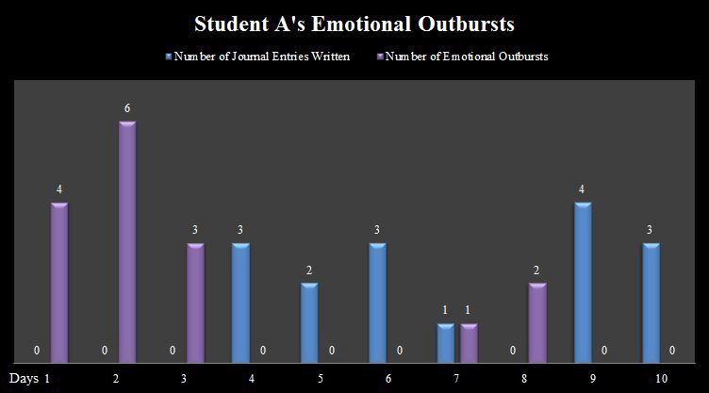

An example of Student A’s journal entries and my response is pictured below:
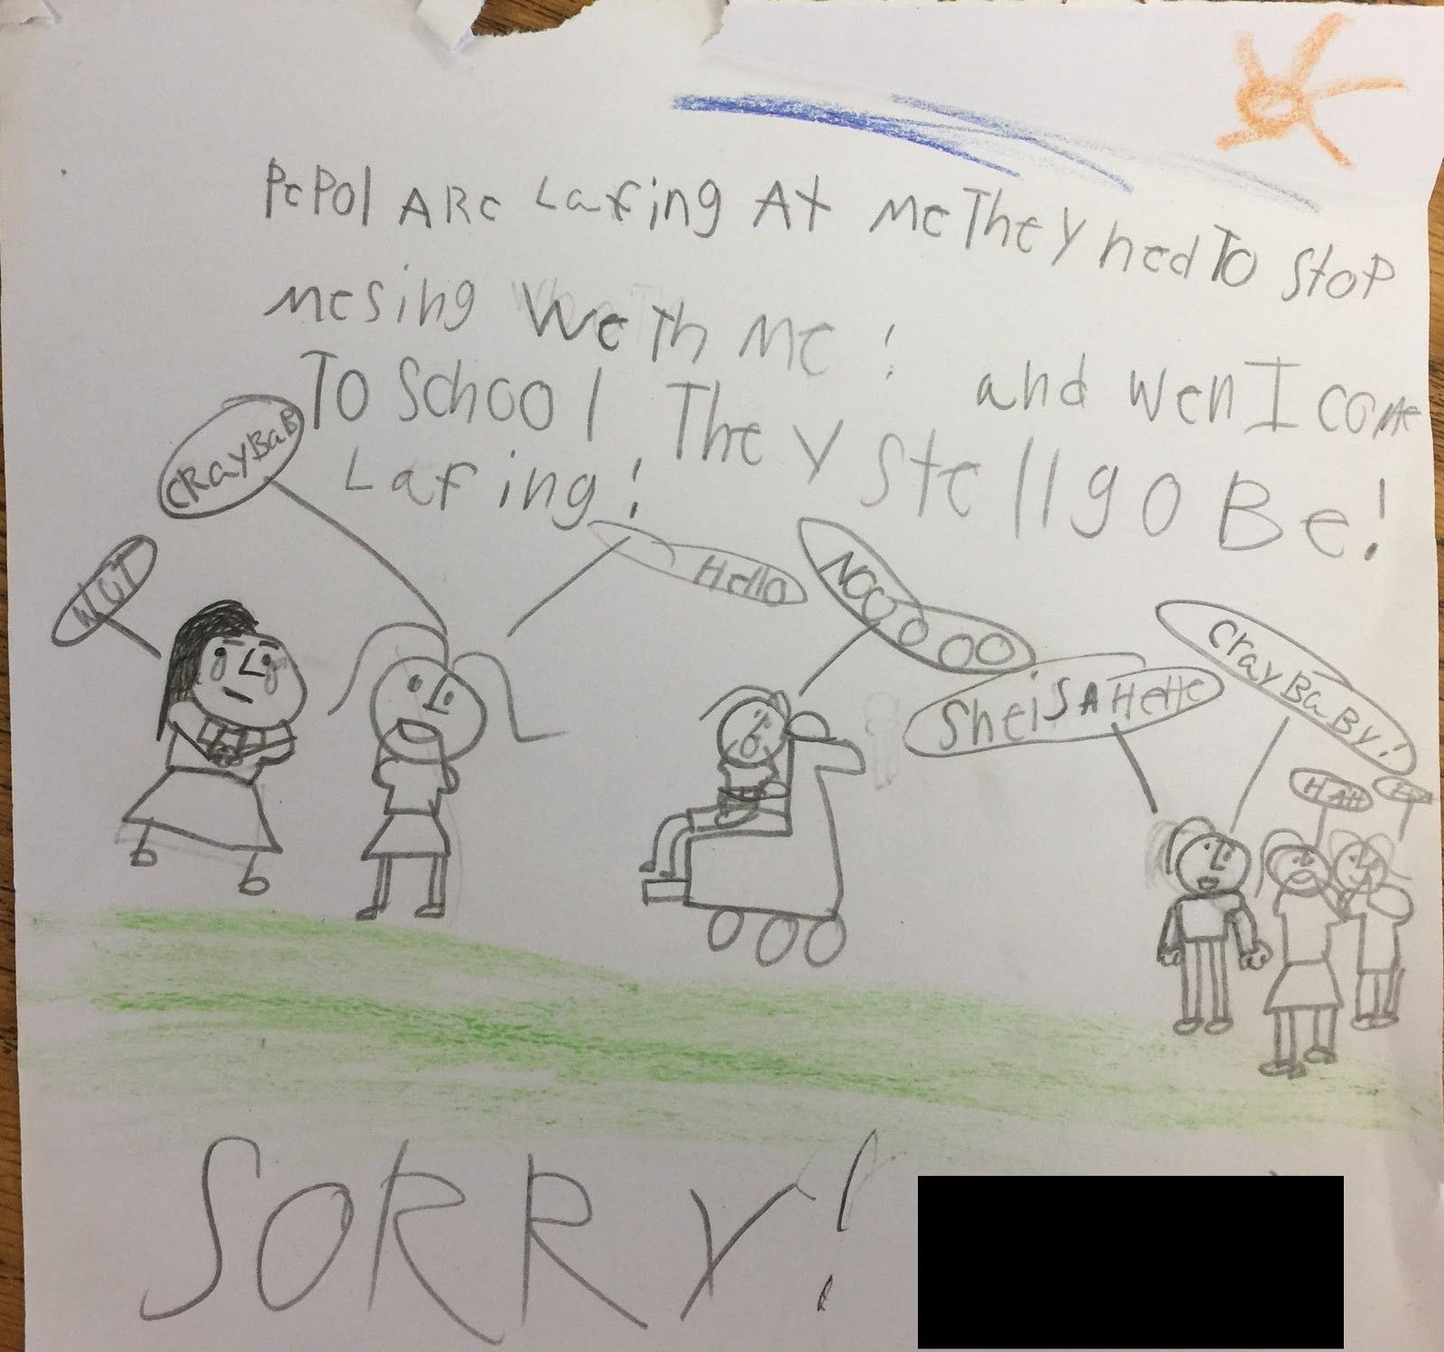

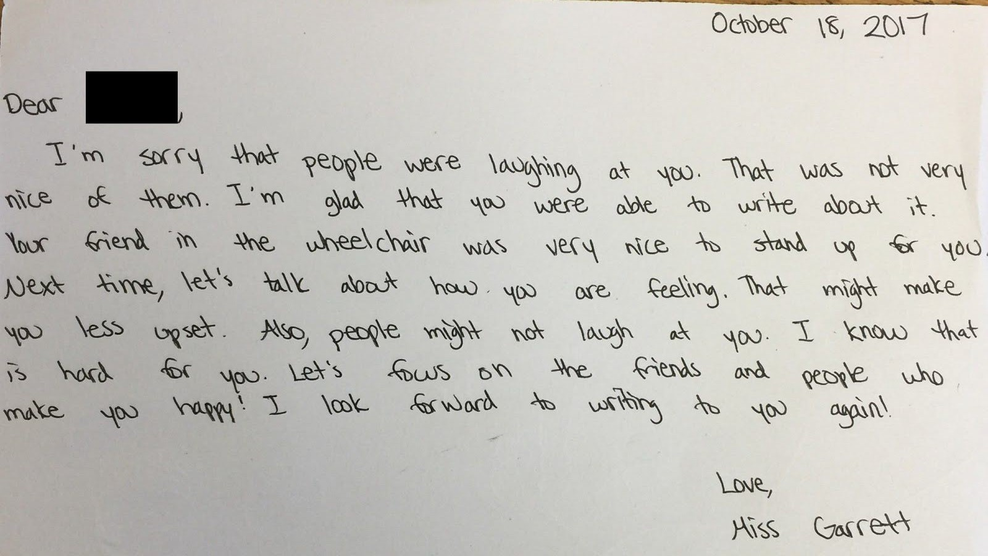

Data Analysis

The data outlined in the table and graph above illustrate the relationship between the number of journal entries Student A wrote daily and the frequency and duration of her emotional outbursts. The first three days of this study involved collecting data without the implementation of the dialogue journals. On these days, Student A experienced no fewer than three emotional outbursts per day. These outbursts ranged between 10 and 36 minutes each. The duration of a few of the outbursts is unknown because she was sent to the office or to another teacher’s room for being too disruptive to the learning process.

After the implementation of the dialogue journals, Student A did not experience emotional outbursts on most days. Although she did exhibit signs of anger or frustration; including furrowing her brow, breathing deeply, and picking the skin off of her hands, she opted to write in her dialogue journal instead of engaging in an emotional outburst. She wrote in her journal up to four times a day for most of these days. On Day 7, she experienced one emotional outburst even though she wrote in her dialogue journal that day. Unlike the other days in which she did not experience emotional outbursts, she only wrote in her journal one time this day. It is evident that this journal entry did have a positive impact on her outburst because her outburst only lasted for five minutes rather than between ten and thirty-six minutes. The one day that she did not write in her dialogue journal resulted in her having two emotional outbursts. The first emotional outburst lasted 18 minutes, and the second one resulted in an office referral. As evidenced by this data, Student A benefitted from the dialogue journals. The more frequently she wrote in her journals, the less frequently she experienced emotional outbursts.

Conclusion

Upon reflection of this data from the action research, it can be concluded that implementing dialogue journals does indeed impact my ability to reach a student struggling with emotional outbursts. The frequency and duration of her outbursts decreased dramatically with the implementation of these journals. On most days, she experienced no emotional outbursts.
Because my methodology was effective, the study did produce the results that I was expecting of a decrease in the frequency and duration of emotional outbursts. The degree of this study’s effectiveness was surprising because the focal student has been experiencing emotional outbursts for the last two years of her schooling. I did not expect for the number of outbursts to decrease so dramatically in such a short period of time. The focal student’s teacher, counselor, and principal attempted to eradicate this issue multiple times. She was even sent to the behavior unit in the school. Her history did not evoke a sense of confidence in the significant impact of the dialogue journals outlined in this data.

Although the data illustrates a great impact on the dialogue journals on Student A’s emotional outbursts, I hesitate to completely attribute the improvement in her behavior to the journals. My involvement in de-escalating her behaviors impacted the frequency and duration of her outbursts. As I began to read and respond to her journals, I developed a relationship with the student and learned how to calm her down. For example, on day five, the student had a furrowed brow when she was asked to come to the carpet. I took the ball that she uses to prevent her from picking the skin off of her hands and used it to play with her. I rubbed it up and down on her nose. Then, I asked for a high-five to show me that she was going to participate in the whole-group instruction on the carpet. After she gave me a high-five, I joked that it was not strong enough and started giving myself high-fives. Interactions such as these impacted the results of my study.

Other factors that influenced the results of my study are environmental factors that influence the focal student’s behavior. My absence on most Mondays and Tuesdays, for example, may have impacted the results of the study because the dialogue journal was not implemented on the days of my absence. The increase in the amount attention she received from Mondays and Tuesdays to the rest of the week may have impacted her behavior because it must have almost felt as if the dialogue journals were being implemented for the first time every week. Other factors, such as classes that the student did not like, the absence and presence of various teachers, and events at home were addressed in the dialogue journals.

Despite the factors that may have skewed the data, I would use this methodology again because the research reviewed above support the use of dialogue journals for forming relationships with students and assisting them with self-regulation. The journals also had an impact on this focal student’s emotional outbursts. She said the journals “make me happy because I like it when all of my feelings can be wrote down.” When asked about the impact of my responses to her journals, the focal student exclaimed, “It makes me happy because I love you so much, but when I stopped using it, I got mad and tore it apart.” The focal student supports my plan to use this methodology again. She says, “it worked because I wrote in it and you did too. I felt better when I used it. It help me calm down.” Upon this interview, the counselor bought the focal student a special “Calm Down Book” for her to use after I leave the classroom.

Plan for Future Action

I would implement this methodology in my future classroom. To do so, I would introduce the use of dialogue journals to the entire class at the beginning of the school year. Although my students will have access to their journals throughout the school day, I will set aside fifteen minutes at the beginning of the day every day for my students to have the opportunity to write about any stresses they are experiencing that may impact them that day. I plan to respond to the journals daily in order to build a positive student-teacher relationship. The results of my study and of the research conducted by other researchers suggest that this effort will decrease the likelihood of excessive negative behaviors associated with emotional and behavioral issues and defiance.

References

Oakdale Primary School. (2016). Retrieved from
https://www.schooldigger.com/go/AL/schools/0336001257/school.aspx

Rappaport, N., & Minahan, J. (2012). Cracking the behavior code. Educational Leadership,
70(2), 18-25.

Regan, K., Mastropieri, M., & Scruggs, T. (2005). Promoting expressive writing among students
with emotional and behavioral disturbance via dialogue journals. Behavioral Disorders, 31(1), 33-50. Retrieved from http://www.jstor.org/stable/23890399

Regan, K. S. (2003). Using dialogue journals in the classroom: Forming relationships with
students with emotional disturbance. TEACHING Exceptional Children, 36(2), 36-41. doi:10.1177/004005990303600205
Smith, A., & Bondy, E. (2007). “No! I won't!” Childhood Education, 83(3), 151-157.
doi:10.1080/00094056.2007.10522900

Staton, J. (1980). Writing and counseling: Using a dialogue journal. Language Arts, 57(5), 514-
518. Retrieved from http://www.jstor.org/stable/41404994

