Office of Research on Teaching in the Disciplines

Undergraduate Action Research Paper No. 19

Manipulatives and Place Value Instruction

by

Emily Altic
The University of Alabama
Department of Curriculum and Instruction
Elementary Education Program

Research Supervisor: Dr. Melisa Fowler

Abstract

Place value is a foundational concept in mathematics that students must learn in order to understand more complex mathematical concepts. One way to teach students the concept of place value is through instruction using manipulatives. This action research study describes how one teacher used concrete and virtual instruction using manipulative to teach place value. Data received prior and post-instruction is compared for analysis. Implications for teaching place value are discussed.
Introduction

This action research study was executed in a public elementary school in the southern United States. The school has a diverse population of 546 students from grades Kindergarten-5. Of these students, 66% are White, 23% are African American, and 9% are Hispanic. Of the student body, 62% qualifies for free or reduced lunch. This study focuses on a fourth-grade inclusion classroom comprised of 25 students with 15 males and 10 females. Of these 25 students, 76% are White and 24% are African American. Additionally, there are six students with an Individualized Education Program (IEP), three who attend speech therapy, three who have been retained for one year and five labeled as gifted. The students with an IEP receive daily intervention with a tutor. The students who attend speech therapy are excused from the class for therapy twice a week. The students who are identified as gifted attend the Gifted and Talented Education (GATE) program once a week.

Place value is a foundational skill essential for students to build upon and learn more advanced concepts. Unfortunately, many of my students during the time this study took place lacked this foundational knowledge as evidenced by their exam scores as well as comments made in class. For instance, when asked how many hundreds are in the number 728, three out of four of my students were unable to correctly respond. Similarly, one of my students was unable to answer how many groups of 10 were in the number 20. These classroom moments led me to decide my students were struggling with place value. Therefore, I concluded many students in the class would benefit from the use of manipulatives to help them visualize quantity value to correctly identify place value. This study explored how the use of concrete and virtual manipulatives impacted my ability to teach place value.

Review of Literature

Manipulative instruction engages students in meaningful learning and provides them with the opportunity to reach a deeper level of understanding. According to Moore (2013), students who learn through the use of manipulatives tend to demonstrate increased, long-term interest in mathematics that further translates to an increase in mathematics proficiency. Students who are exposed to manipulatives on a weekly basis prove to be up to 72% of a grade level ahead in mathematics (Moore). Manipulatives may help students internalize concepts that are otherwise abstract (Gersten et al., 2009). This form of instruction can be utilized to aid understanding for students of all ability levels. In particular, students who appear to be missing a foundational concept have been found to benefit from the use of manipulatives (Moore).

A tool often used for developing understanding is Base-10 blocks. Using manipulatives such as Base-10 blocks is important to aid students struggling with foundational concepts such as number computation and place value (National Center of Intensive Intervention, 2015). In addition to concrete manipulatives like Base-10 blocks, virtual manipulative instruction has proven to be effective in aiding student learning (Bouck & Flanagan, 2010). A virtual manipulative has been described by Bouck and Flanagan as interactive and web-based. It is a visual representation of a dynamic object that presents opportunities for constructing mathematical knowledge. Virtual manipulatives are exciting for students and allow students to engage in meaningful learning and internalize mathematical concepts (Mikyung, 2004).

Procedures

At the beginning of this action research study, I implemented the pre-assessment in Figure 1 to compile information about the needs and prior knowledge of my students. This pre-assessment consisted of a written assessment about place value. I scored these assessments to get a general idea of what specific areas caused students to struggle the most. If a student missed none or only one question, the student was exempted from further instruction as this result indicated an understanding of place value. Students missing two or more problems on the assessment, were required to participate in the study as this indicated they may not have a foundational understanding of place value. Eleven students ended up participating in the study.

Individual Pre-assessment without Manipulatives Available
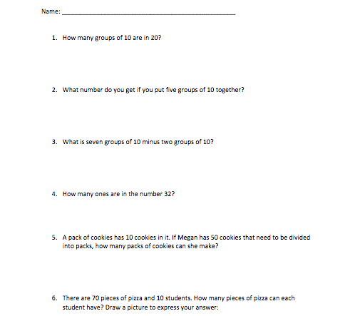

Figure 1. Individual pre-assessment without manipulatives available

After this first phase of the study, I provided the students with instructions for using Base-10 blocks, which are concrete manipulatives. Students were shown how to utilize these manipulatives to solve word problems and develop an understanding of place value. Each student was provided with small group instruction and given the opportunity to use the manipulatives to form numbers and complete the list of problems seen in Figure 2.

List of Problems Approached in Small Groups with Base-10 Blocks
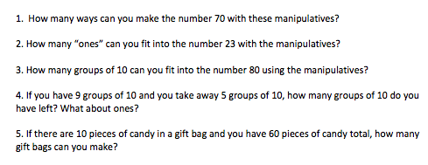
Figure 2. List of problems approached in small groups with Base-10 blocks

After the students completed the list of problems, they took an assessment similar to the pre-assessment. The students were encouraged to use the manipulatives throughout the assessment. The students’ scores were recorded and charted. The second assessment is found in Figure 3. :

The students then received small group instruction in virtual manipulatives to explore place value. The virtual manipulatives were Base-10 Blocks from the website www.abcya.com/base_ten.htm. The students used the virtual manipulatives to complete a list of problems identical to the list of problems completed using the concrete manipulatives. After students received sufficient instruction in the use of virtual manipulatives, they were given a virtual manipulatives post-assessment similar to the pre-assessment but with varying numerical values (see Figure 4). The results from this post assessment were recorded and charted.

Individual Post-Assessment with Base-10 Blocks Available to Students
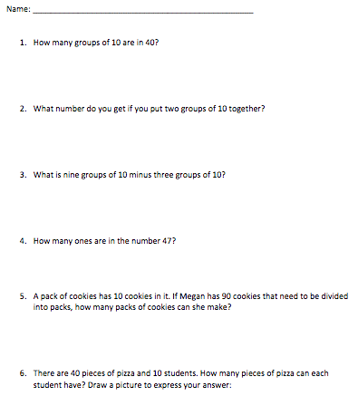
Figure 3. Individual post-assessment with Base-10 blocks available to students

The students then completed a survey about how they felt about the research, which manipulatives they preferred, and their personal opinions concerning whether they felt manipulatives enhance their experience with math instruction. See Table 1 for timeline of the study.

Individual Post-Assessment with Virtual Manipulatives Available
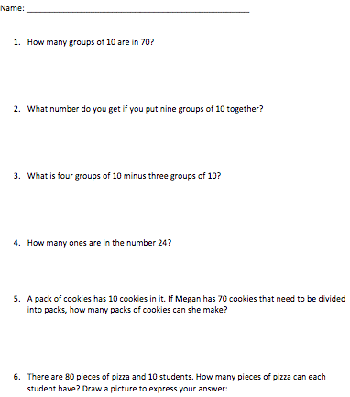

Figure 4. Individual post-assessment with virtual manipulatives available

Table 1
Timeline
Day # | Time required/ group | Instruction
1 | 20 minutes/whole group | Collect data to compile information about the needs and prior knowledge of students
2 | 10 minutes/me | Grade pre-assessments to determine which students will participate in the study
3-5 | 15 minutes/small group | Provide participating students with concrete manipulatives; students are instructed in the use of these manipulatives and complete a practice task  Record observations about student understanding and performance
6 | 20 minutes/small group | Provide participating students with concrete manipulatives post-assessment similar to the pre-assessment but with different numerical values; students may use concrete manipulatives  Record observations about student understanding and performance
7-9 | 15 minutes/small group | Provide participating students with virtual manipulatives; students are instructed in the use of these manipulatives and complete a practice task  Record observations about student understanding and performance
10 | 15 minutes/small group | Provide participating students with virtual manipulatives post-assessment similar to the pre-assessment but with different numerical values; students may use virtual manipulatives  Record observations about student understanding and performance
10 | 15 minutes/individual | Students complete survey about how they felt about the research, which manipulatives they preferred, and their personal opinions concerning whether they felt manipulatives enhance their experience with math instruction.  Record observations about student understanding and performance

Data Analysis

As evidenced by the data, each of the students showed growth in their knowledge of place value as seen in their increased scores on the assessments. Every student exhibited an increase in percentage when comparing his or her pre-assessment score to the virtual post-assessment score (i.e., the test in which students were allowed to use virtual manipulatives). See Table 2.

Table 2
Comparison of Scores
Student Name | Pre-Assessment (%) | Concrete (%) | Virtual (%)
Jayden | 66 | 66 | 83
Jacob I | 66 | 66 | 100
Tristan | 50 | 83 | 100
Jadyn | 50 | 100 | 100
Terrence | 0 | 100 | 100
Bailey | 66 | 100 | 100
Jacob W | 16 | 100 | 100
Brandon | 50 | 100 | 100
Hayden S | 50 | 83 | 83
Austin | 50 | 66 | 83
Keaton | 0 | 0 | 16
Average (%) | 42.1 | 78.5 | 87.7

The average score of the pre-assessment was 43%, while the average score of the concrete post-assessment (i.e., the test in which they were allowed to use concrete manipulatives) was 78.5%, and the average score of the virtual post-assessment was 87.7%. The students’ scores steadily increased with each assessment. The increase in student scores can be viewed in the line graph in Figure 5 showing the increase in scores with each assessment as the students’ developed a heightened understanding of place value.

Figure 5. Place value with manipulatives assessment data

The students appeared to be actively engaged in each phase of instruction and their scores steadily increased. In an interview following the study, all 11 students who participated reported their favorite form of instruction was the virtual manipulative instruction.
Conclusion

After evaluating and analyzing the results of my action research study, I believe instruction with manipulatives impacted my ability to aid student understanding of place value using virtual and concrete manipulatives. The students demonstrated a vast improvement in understanding of place value when the average scores of their pre and post-assessments were compared. In the pre-assessment, the students scored an average of 42.1%. This re-affirmed my conclusion that it would be beneficial to provide the students with manipulative instruction to aid their understanding of place value. After experiencing both concrete and virtual manipulative instruction for several days, the students completed their virtual post-assessment. On this assessment, the students scored an average of 87.7%. This score leads me to conclude student understanding increased due to the inclusion of concrete and virtual manipulatives.

I recommend implementing this methodology for other foundational mathematical concepts (e.g., whole number computation, quantity value, or addition and subtraction). It is interesting to consider how students may benefit from manipulative instruction on a multitude of mathematical concepts over a lengthened period. On a similar note, this study took place over a period of ten days and I am keen to find out how incorporating manipulatives into ongoing, daily instruction could further benefit my students.

References

Bouck, E. C., & Flanagan, S. M. (2010). Virtual manipulatives: What they are and how teachers can use them. Intervention in School and Clinic, 45(3), 186-191.

Gersten, R., Beckmann, S., Clarke, B., Foegen, A., Marsh, L., Star, J. R., & Witzel, B. (2009). Assisting students struggling with mathematics: Response to intervention (RtL) for elementary and middle schools (Institute of Education Sciences Practice Guide). Washington, DC: U.S. Department of Education. Retrieved from https://ies.ed.gov/ncee/wwc/Docs/PracticeGuide/rti_math_pg_042109.pdf.

Mikyung, S., (2004). Virtual manipulatives, Intervention in School and Clinic, 52(3), 148-164.

Moore, S. D. (2013). Teaching with manipulatives: Strategies for effective instruction, Colorado Mathematics Teacher. Fall Issue. Retrieved from www.cctmath.org.

National Center on Intensive Intervention (2015). Place value concepts. Washington, DC: U.S. Department of Education. Retrieved from https://intensiveintervention.org/sites/default/files/PlaceValueComp_508.pdf.

