Excellence in Teaching Awards

http://education.ua.edu/centers/ortd/

Call for Nominations

A teacher’s impact upon their students cannot be underestimated. The University of Alabama’s Office of Research on Teaching in the Disciplines wishes to recognize how Alabama teachers, pre-Kindergarten – 16, create excellence in their classrooms every day.

We are asking teachers to share their unique ideas or to nominate another teacher who makes learning engaging, interactive, and memorable for students.

A plaque for Excellence and Honorable Mention can be awarded in each disciplinary area. Certificates of Recognition also are awarded. Note: Teachers may submit a single lesson in only one of the following categories:

- Excellence in Cross-Disciplinary Teaching (P-12) (across two of the categories below)
- Excellence in Teaching Early Childhood Education (infants through 3rd grade)
- Excellence in Teaching English as a Second Language
- Excellence in Teaching English/Language Arts (P-12)
- Excellence in Teaching Gifted Studies
- Excellence in Teaching Physical Education (P-12)
- Excellence in Teaching Mathematics (P-12)
- Excellence in Teaching Science (P-12)
- Excellence in Teaching Social Studies (P-12)
- Excellence in Teaching Special Education (P-12)
- Excellence in Teaching with Technology in the Disciplines (P-12)
- Excellence in Teaching World Languages
- Excellence in Undergraduate Teaching (freshman-senior levels)

Teachers engaged in the National Board certification process can use participation in this award project to address the 4th category of “Learning Communities”.
Deadline for submissions is February 15, 2019, 4:45 pm to cvsunal@ua.edu
Submission Cover Page
Use the following submission format to submit one lesson. The lesson demonstrates exemplary teaching in your discipline. Please submit the cover page and lesson plan as two separate email attachments to Cynthia Sunal at cvsunal@ua.edu).
Note: If you are nominating someone else, please provide an email address for the nominee and we will make a contact and request the information below.
- Title of Submission:
- Category of Award for which this submission is intended (fill in the blank with one of the bulleted options below):
Excellence in ________________________________________
- Excellence in Cross-Disciplinary Teaching (P-12) (across two of the categories below)
- Excellence in Teaching Early Childhood Education (infants through 3rd grade)
- Excellence in Teaching English as a Second Language
- Excellence in Teaching English/Language Arts (P-12)
- Excellence in Teaching Gifted Studies
- Excellence in Teaching Physical Education (P-12)
- Excellence in Teaching Mathematics (P-12)
- Excellence in Teaching Science (P-12)
- Excellence in Teaching Social Studies (P-12)
- Excellence in Teaching Special Education (P-12)
- Excellence in Teaching with Technology in the Disciplines (P-12)
- Excellence in Teaching World Languages
- Excellence in Undergraduate Teaching (freshman-senior levels)

- Contact Information:
  - Teacher’s Name:
  - Teacher’s Email Address:
  - Name of School/Institution:
  - Name of School System or Agency:
  - Name, Address, and Email Address of Principal or Immediate Supervisor:
  - Name, Address, and Email Address of Superintendent or Chief Administrator:

- Teacher’s Biography (50 words maximum):

Lesson Plan Submission Form

Lesson Plan Overview
Note: The boxes below will expand as you type into them.
Age, Grade Level, or Class Distinction of Students: (e.g., college freshmen)
Subject, Disciplinary, or Content Area:
Purpose: (include connections to Alabama and national/core standards)
References/Source(s): List curriculum sources, if applicable, that you used in the lesson. Example: A premade lesson from a curriculum or teacher’s guide that you have modified to meet the needs of your students. Note: Preference is given to originality and innovation.
Explanation of Modification(s): (include brief description of how premade lesson or curriculum was modified to fit the needs of your students and the goals of the lesson)
Picture(s): (not required; maximum of five allowed). All pictures must be inserted into this submission form and will not be accepted as separate attachments or links. Pictures may include student work, projects, screenshots, graphic organizers etc. Note: Do not include pictures that display student faces or names.  To insert a picture, first make sure the picture is saved to the Pictures or My Pictures location on your computer. Select the Insert option near the top, left of your screen. Choose Pictures. Select the picture you would like to insert. Select Insert. | StockFreeImages.com  Insert pictures, if applicable (maximum of five), in this box.  To adjust the size of a picture: Once a picture is inserted, you can adjust it to an appropriate size by clicking on the picture and choosing the Format option that will appear in the top, middle of your screen. You can also click, hold, and drag the edges of the picture to adjust its size. Delete the example image and information in this box from your submission by using the Backspace or Delete keys on your keyboard.
PowerPoint Slide(s): (not required; maximum of ten allowed). All presentation slides must be inserted into this submission form and will not be accepted as separate attachments or links.  Detailed directions: https://support.office.com/en-us/article/link-or-embed-a-powerpoint-slide-in-a-word-document-2e421b6d-dd5d-4e3b-a0c7-dc9732d0da01 | 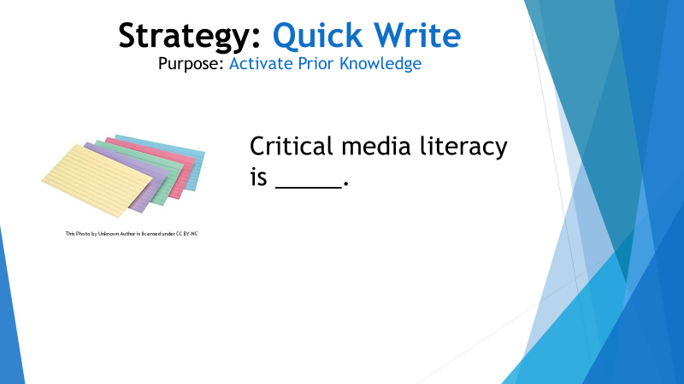  Simplified directions: Open your PowerPoint. On the left side of your screen, you should see an area where small preview panes of your slide are visible.  Right click the small preivew pane of the slide you wish to insert into Word. Copy the slide and paste it into this box. You can click on the picture to adjust its size by dragging the edges or by using the Format option at the top of the screen. Delete the example image and information in this box from your submission by using the Backspace or Delete keys on your keyboard.
Additional Materials: (including lists of manipulatives, art supplies, worksheets, graphic organizers, video links with brief descriptions, etc.)

Objectives: | - Students will  - Students will  - (add as needed)
Procedures: (Include procedures for differentiating instruction)
Exploration/Introduction: Discuss the beginning of the lesson; including the rationale for what took place.
Lesson Development: Provide an overview of how the lesson unfolded; including concise descriptions of lesson activities and rationales.
Expansion/Application Activities: Describe how students were able to apply the knowledge/experience of the lesson. Describe any extending activities and provide the rationale for including these activities, reflections, projects, and/or discussions.
Assessment: How have you identified measurable results that let you know whether your students have mastered the objective(s)?
Reflection: (How do these instructional decisions impact student learning?)
Any Additional Useful Information:

If this lesson is from a unit, give a brief description of the Unit (not required):

Teacher’s description of why this lesson was exemplary when taught (may include rationale, innovation, impact etc.):

______________________________________________________________________
Excellence in Teaching Award Rubric
Teaching in the Disciplines
2017-2018
Date of Electronic Submission:
Submitted by:
Reviewer:
Scoring Criteria:
1 = Lacking Condition Components in Lesson Plan Submission
2 = Adequate Condition Components in Lesson Plan Submission
3 = Exemplary Condition Components in Lesson Plan Submission (Innovative, Original, Creative)

Lesson Plan Targets
Condition | Components | Comments | Score: 1-3
Lesson Plan  Target | Clear description of school profile; classroom age/grade; subject and/or disciplinary area of lesson plan’s target. |  | /3

Lesson Plan Purpose | Clear purpose for this lesson plan. Brief discussion of how this lesson follows previous lessons addressing a short and/or long-term goal. Includes Alabama and national/core standards. |  | /3

Lesson Plan Materials | Clear listing of all necessary materials. |  | /3

Lesson Plan Objectives | Clearly written objectives that interconnect purpose and appropriate assessments for lesson plan. |  | /3

Lesson Plan Procedures | Clearly organized steps in lesson plan instructional procedures that address:  - Concept Development  - Prior Experiences and Knowledge  - Introduction/Explanation  - Objectives  - Meaningful Practice  - Expansion/Application  - Appropriate Time Length of Activities  - Accommodations for Diverse Learners  - Closure  - Meaningful Application  - Transference of Lesson Concept to New Setting |  | /3  x3 =

Lesson Plan Assessments | Copies of assessments during and at the end of the lesson are included |  | /3

Instructional Reflection: | How do these instructional decisions impact student learning? |  | /3
Lesson Plan Supporting References | Clearly stated supporting references for the lesson plan. |  | /3

 | Additional Comments: | TOTAL  /30

Review Process
- All submissions will be acknowledged with a notification of receipt.
- Submissions that do not meet the submission guidelines will be returned with the opportunity to resubmit available until February 15, 2019 4:45 pm.
- Submissions must include only two attachments: 1) Cover Page and 2) the Lesson Plan Submission Form (including the rubric above). Google Drive and other links will not be accepted.
- Each award will be reviewed by a sub-committee of specialists from The Office of Research on Teaching in the Disciplines. Awards will be announced in late spring.
For further information contact: Cynthia Sunal, The University of Alabama, cvsunal@ua.edu, 205-348-8264

